ASSIGNMENT-1

SDLC: SOFTWARE DEVELOPMENT LIFE CYCLE:
1. Prototype Model
2. Iterative Model
3. Spiral Model
4. Rapid Application Development Model

1. Prototype Model:
The prototype model is a system development method. A prototype model is a involves buildings, testing, and improving a prototype until it means exception.
Prototype model is a tested and refined as per customer needs.
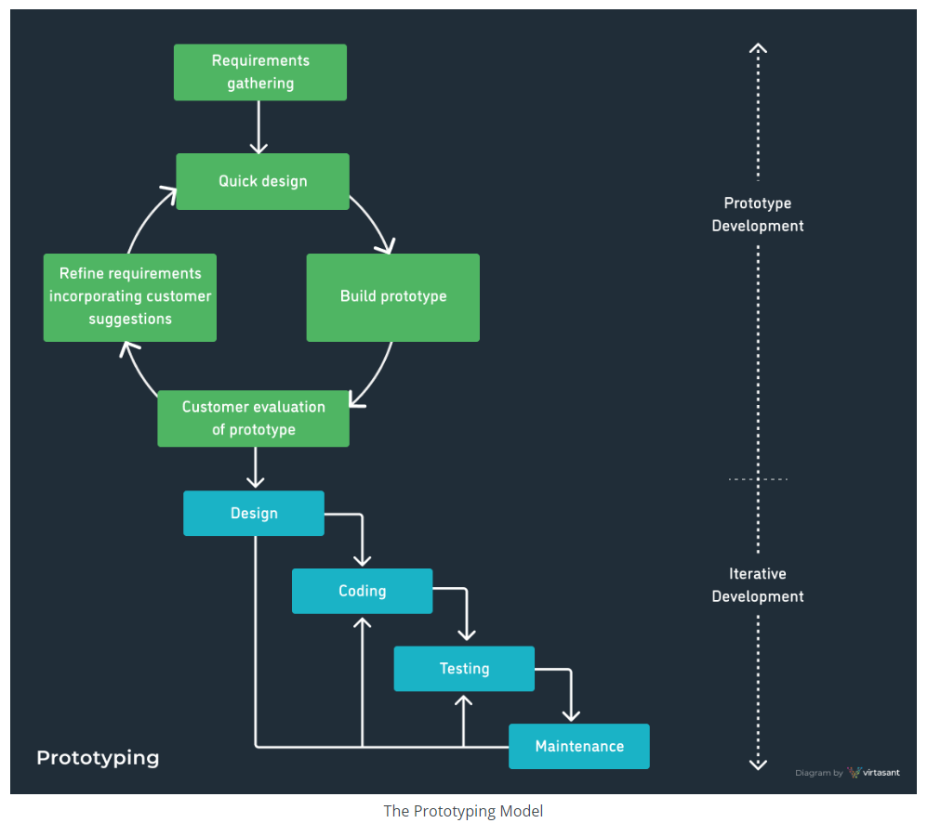
2. Iterative Model:
The iterative model is a breakdown projects into smaller, manageable chunks called iteration.
Each iteration involves planning, analysis, design, development, testing, and deployment.
Iterative model is a includes the main phases:
Design, prototype and planning.

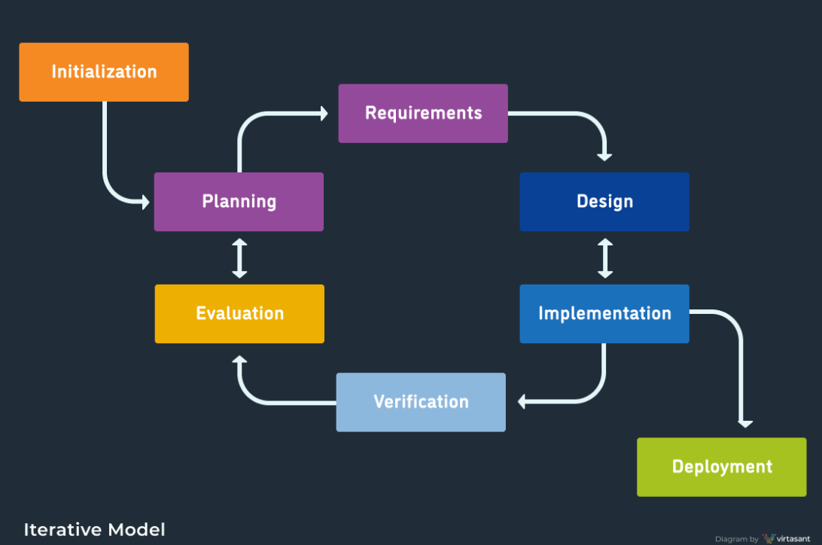

3. Spiral Model:
The spiral model is software development life cycle method. A spiral model is a combines the iterative development model with elements of the waterfall model. Spiral model overcome drawbacks of waterfall model.
These model includes the main phases: Planning, risk analysis, product development and planning.
In every cycle new software will be released to customer
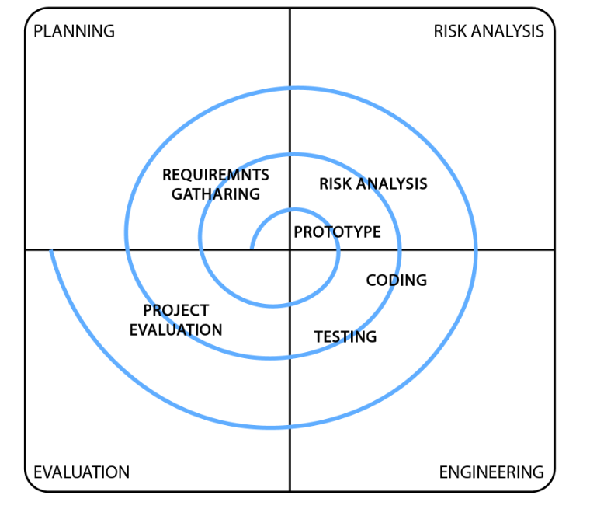

4. Rapid Application Development Model:
The rapid development application model is a reduction in planning to focus on highly iterative design and construction process. This model used for reducing the time and cost.
This model includes the phases:
Business modelling, data modelling, process modelling, application modelling and testing and turnover.
